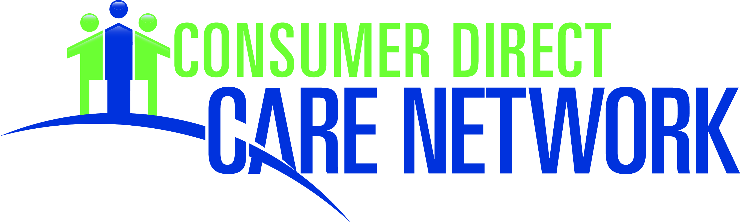

PhotographReleaseCDCN_20160912

I forever release CDPC from any and all claims, actions and demands arising out of or in connection

with the use of these representations, including any and all claims for invasion of privacy and libel. This release shall include the subsidiaries, assigns, licensees, legal representatives, and related entities of CDCN.

**RELEASE AND AUTHORIZATION FOR**

**USE OF PERSONAL REPRESENTATIONS**

Thank you for allowing the members of the Consumer Direct Care Network to use your personal representation. We hope that this will further our goal of bringing independent living principles to individuals in their homes and communities.

**Permission:**

I hereby grant Consumer Direct Holdings, Inc., its subsidiaries and assigns (the “Consumer Direct Care Network” hereinafter “CDCN”) the right and permission to use photograph(s), video(s), voice recordings, quotations, or other representations that were taken of me including the use of my name in connection with these representations. I grant CDCN the right to use and reuse these representations:

•

•

•

•

•

in whole or in part,

modified or altered,

either by themselves or in conjunction with other representations, in any medium or form of distribution,

for any purposes whatsoever, including all promotional, advertising, and other trade uses.

If permission is requested in writing to cancel the use of the representation(s), CDCN will

discontinue using it in future print editions, productions, and other mediums. However, CDCN will use up any existing supply of printed materials and utilize any current television or radios spots through their typical life cycle. I grant CDCN the right to use these representations:

from this date forward and until canceled in writing

or

for a period of years

Authorized:

(if Applicable)

Guardian Name

*Signature (Guardian if under 18) Date*

[ ]

[ ]

Phone:

Address:

Name: